R. Reports Menu: 3. Cash Receipts

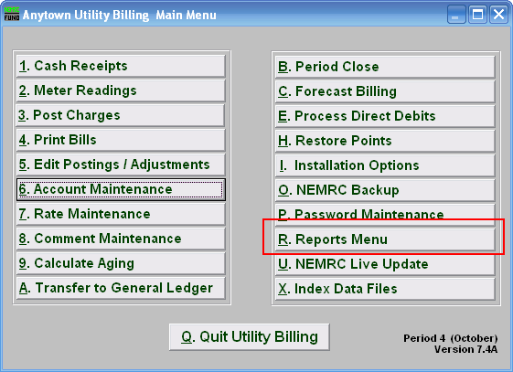
Click on “R. Reports Menu” from the Main Menu and the following window will appear:

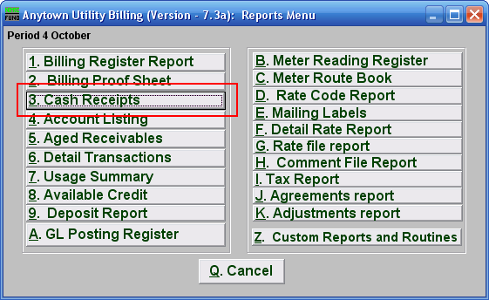
Click on “3. Cash Receipts” from the Reports Menu and the following window will appear:
Cash Receipts Report

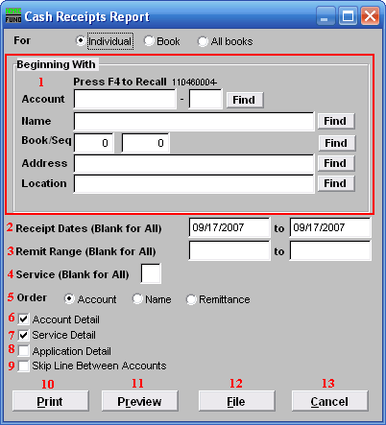
- Beginning With: If you choose “Individual,” choose the account you want to begin with. For additional help on finding accounts, refer to UB GENERAL ACCOUNT LOOKUPS. If you choose “Book,” choose the Book you wish to forecast billing for. If you choose “All Books,” this section will not be available.

- Receipt Dates (Blank for All): Dates of cash recording to report. Commonly used for activity balancing to bank deposit for each day. Leave blank to use all dates.

- Remit Range (Blank for All): Remittance number range to report. Most users do not track remittance numbers during cash processing. This would allow multiple deposits during a single day.

- Service (Blank for All): The service to show on this report. Leave blank to show all services. Services are defined in “I. Installation” from the Main Menu.

- Order: Click the circle next to the order you want the information to appear on the report.

- Account Detail: Click this box to show a listing for each account with records to report.

- Service Detail: Click this box to show the detail for each service within the account information.

- Application Detail: Click this box to show the type of activity (bill, interest, penalty, credit, deposit) on the report.

- Skip Line Between Accounts: Click this box to have a line between accounts for marking up the report or for visual appearance.

- Print: Click this button to print this report. Refer to GENERAL PRINTING for more information.

- Preview: Click this button to preview this report. Refer to GENERAL PREVIEW for more information.

- File: Click this button to save this report on this computer. Refer to GENERAL FILE for more information.

- Cancel: Click “Cancel” to cancel and return to the Reports Menu.

